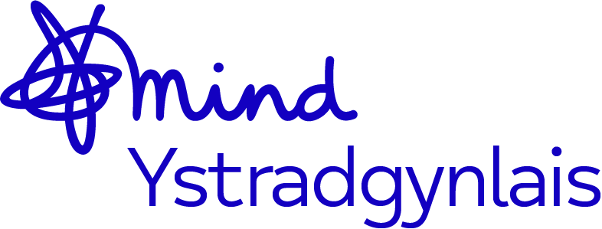
Mind Ystradgynlais Counselling Payment Policy
At Mind Ystradgynlais, we are committed to providing accessible counselling services. Due to dangerously low funding, we now require payments to sustain our counselling service. Please read the following policy carefully before booking your sessions.

Payment Policy
- All payments are non-refundable.
- Counselling consists of six sessions, each lasting 50 minutes.
- Payment is required at least 48 hours before your scheduled session.
- We encourage clients to make weekly payments, (assuming your counselling sessions occur once a week) as you may not require all six sessions. Weekly payments offer greater flexibility.
- No cash payments are accepted—all payments must be made online. We do not hold cash on the premises, and your counsellor will never request cash from you.

Payment Confirmation & Reminders
- You will receive one text or email message to confirm your payment.
- If payment is not received at least 48 hours before your session, your session will be cancelled.
- A text and email notification will be sent informing you of the cancellation.

Missed Sessions, Cancellations & Withdrawing from Counselling
- If you have paid but do not attend, your session will be lost and cannot be rescheduled.
- If you have not paid and still attempt to attend your session, you will be turned away, as your session will have been cancelled.
- If you choose to withdraw from counselling before completing all six sessions, payments will not be refunded.
- Missed sessions will not be refunded under any circumstances.
- Individual contracts will be created with your therapist to outline boundaries and further details.
- As a general rule, if you miss two sessions, we will assume you no longer wish to access the service and remove you from our lists.
- If we attempt to contact you twice and receive no response, we will also assume you no longer wish to access the service and remove you from our lists.

Eligibility for Free Sessions
- If you receive benefits, you may be eligible for three additional free sessions after your initial three.
- Proof of benefits must be provided, dated within the past two months.

For Clients Referred When Counselling Was Free
- Unfortunately, due to critically low funds, we have had no choice but to introduce a payment system for counselling sessions. We appreciate your understanding and support during this time.

For any questions or concerns, please contact us before booking your sessions. Thank you for supporting Mind Ystradgynlais and enabling us to continue providing vital mental health services.

Policy created: 29/1/25
Policy revised on 8/2/25
Signed off by board of trustees: 26/2/25
To be reviewed: Jan 2027

